User’s Manual

For

Language Learners United over 9000

Michael Cottrell

**Table of Contents**

1 Introduction 3

1.1 Purpose 3

2 Application Usage 3

2.1 Main Menu 3

2.2 Flash Card Game 4

2.3 Facts 6

2.3 Webmail 6

2.4 Search Users 8

2.5 Settings 8

# 1 Introduction

## 1.1 Purpose

The purpose of this document is to explain how to use the Language Learners over 9000 (LLUO) web application, so that users may have an easier time navigating the application.

1.2 Audience

The audience for this project is anyone who would like to learn more about their language of choice, or want games to play, and ways to contact people who know the language they wish to learn.

1.3 Security

Any sensitive information like passwords will be stored in a manner which is consistent with modern security protocols.

# 2 Application Usage

## 2.1 Main Menu

The main menu (pictured below) will be the first screen after logging in. From here you can access settings and all functionality aspects of the site. 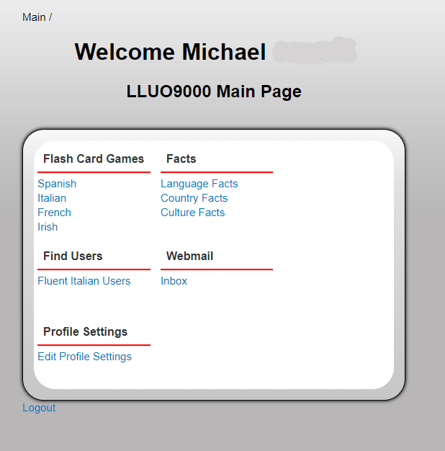

## 2.2 Flash Card Game

* + 1. The first functionality is the flash card game. This can be reached from the main menu. For an average user, only the language you wish to learn will have a flash card game available. However, you can change which language you wish to learn at any time in the settings screen.
    2. Getting There & Basic Use



* + 1. Navigating words



## 2.3 Facts

1. Getting There
   1. Once logged in and at the main menu there is a header for “Facts”. Underneath this header is three links, just click the one you want. There is “Language Facts”, “Country Facts”, and “Culture Facts”. They will take you to the page to view them, refresh the page to see different facts of the same type.

## 2.3 Webmail

* + 1. Image of Webmail interface

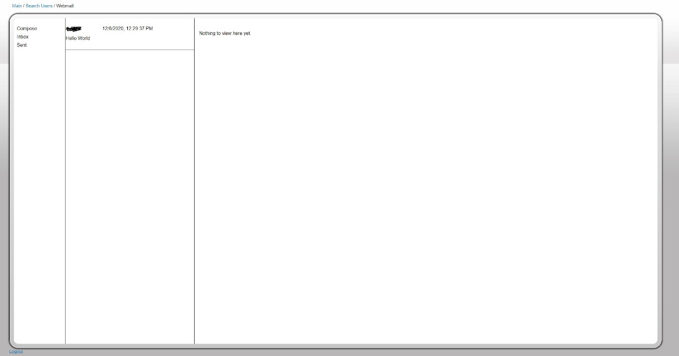

* + 1. Getting There
       1. Once logged in and at the main menu there is a header for “Webmail”. Click the link for inbox to get to the webmail page. Alternatively go to section 2.4 for search users to access the webmail.
    2. Inbox
       1. When entering webmail from the main menu, the default view is your inbox view. You can also come back to this view by clicking on “inbox” in the first column. This shows all messages you have received in the second column. Clicking on one of these messages shows it in the third column with a text-box to reply to the message.
    3. Sent
       1. Clicking on “sent” in the first column will show all messages you have sent in the second column. You can view and reply to these messages just like those in the inbox.
    4. Compose
       1. Clicking on “Compose” will allow you to write a new message to your contacts.
    5. Contacts
       1. You can add people to your contacts by finding a user via section 2.4 and sending a message to them, or by receiving a message from a user. Then you can send messages to them at any time.

## 2.4 Search Users

* + 1. Image of Search Interface

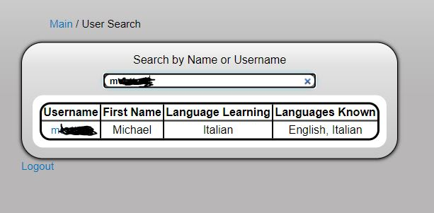

* + 1. Getting There
       1. Once logged in and at the main menu there is a header for “Find Users”. Click the link below the header for to be taken to the User Search page.
    2. Searching for Users
       1. Upon entering the page a list of users who know the language you are trying to learn will appear. You can narrow this search entering text into the search field and hitting enter. This will narrow the search by username or first name.
    3. Messaging Found Users
       1. Once you decide to message a user you can click on their name and it will bring you to the webmail interface and to writing a message to that user. Just enter your message and hit send.

## 2.5 Settings

* + 1. Getting There
       1. Once logged in and at the main menu there is a header for “Profile Settings”. Click the link below the header for to be taken to the edit settings page.
    2. Changing Settings
       1. Here you can change your name, email, language preference, or password. You can skip password change by leaving it blank. You can change all the fields by changing them and hitting save.

# 3 Disclaimer

## 3.1 Browsers

1. It is recommended to use Chrome, Microsoft Edge, or Firefox
2. All other browsers including mobile devices may not work as intended.